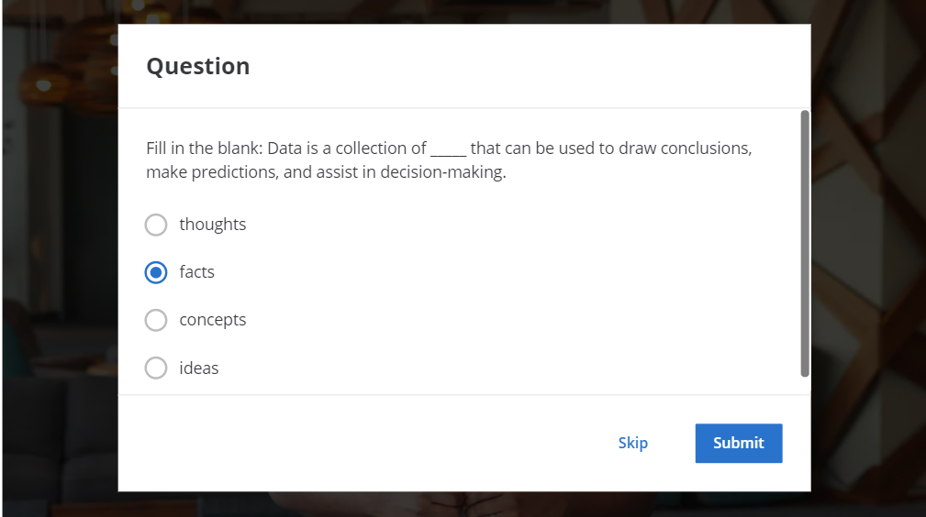

Question 1

## **Optional speed track for those experienced in data analytics**

The Google Data Analytics Certificate provides instruction and feedback for learners hoping to earn a position as an entry-level data analyst. While many learners will be brand new to the world of data analytics, others may be familiar with the field and simply wanting to brush up on certain skills.

**If you believe this course will be primarily a refresher for you, we recommend taking this practice diagnostic quiz.** It will enable you to determine if you should follow the speed track, which is an opportunity to proceed to Course 2 after taking each of the Course 1 Weekly Challenges and the overall Course Challenge. Learners who earn 100% on the diagnostic quiz can treat Course 1 videos, readings, and activities as optional. Learners following the speed track are still able to earn the certificate.

**If you aren't familiar with data analytics, this course was made for you! Feel free to skip this quiz and move forward through all of the course material.**

Get ready to take the next step in your data analytics journey with the question below!

https://d3c33hcgiwev3.cloudfront.net/imageAssetProxy.v1/5tMk6a2uQvWTJOmtrrL1vA_bb1334a071f749898c0cdc801d81ac2b_graphic-line-right.png?expiry=1635984000000&hmac=1OTJQoHoV6qcXpkjuQg9jSvLQnR7eUuM1y6zSbECAZo

A clothing retailer collects and stores data about its sales revenue. Which of the following would be part of its data ecosystem? Select all that apply.

**0.5 / 1 point**



The database of sales revenue

**Correct**

The clothing retailer’s data ecosystem would include the database of sales revenue, the cloud that stores the database, and records of its inventory. A data ecosystem is the various elements that interact with one another in order to produce, manage, store, organize, analyze, and share data.



The cloud that store its database



The databases of competing retailers



Records of its inventory

You didn’t select all the correct answers

### 2.

Question 2

What is the process of guiding business strategy using facts?

**1 / 1 point**



Data-driven decision-making



Strategic improvement



Identification of data and decisions



Analytical planning

**Correct**

Data-driven decision-making is the process of guiding business strategy using facts.

### 3.

Question 3

Fill in the blank: Curiosity, understanding context, having a technical mindset, data design, and data strategy are _____. They enable data analysts to solve problems using facts.

**1 / 1 point**



analytical skills



thought processes



business skills



personal insights

**Correct**

Curiosity, understanding context, having a technical mindset, data design, and data strategy are analytical skills. They enable data analysts to solve problems using facts.

### 4.

Question 4

The owner of a skate shop notices that every time a certain employee has a shift, there are higher sales numbers at the end of the day. After some investigation, the owner realizes that since the employee was hired, the store earns 15% more each month. In this scenario, the manager used which quality of analytical thinking?

**1 / 1 point**



Visualization



Big-picture thinking



Problem-orientation



Correlation

**Correct**

The owner used correlation, which involves being able to identify a relationship between two or more pieces of data. They noticed that there is a correlation between the employee’s presence and the skate shop’s traffic and monthly income.

### 5.

Question 5

Gap analysis is a process that could help accomplish which of the following tasks? Select all that apply.

**1 / 1 point**



Spread awareness about income inequality based on local salaries



Increase the efficiency of a car manufacturer based on its current assembly process

**Correct**

Gap analysis is a method for examining and evaluating how a process works currently in order to get where you want to be in the future. Improving accessibility, increasing efficiency, and reducing carbon emissions are examples of improvements that gap analysis can help accomplish.



Improve accessibility for an educational app based on its current functionality

**Correct**

Gap analysis is a method for examining and evaluating how a process works currently in order to get where you want to be in the future. Improving accessibility, increasing efficiency, and reducing carbon emissions are examples of improvements that gap analysis can help accomplish.



Reduce a company’s carbon footprint based on its current emissions

**Correct**

Gap analysis is a method for examining and evaluating how a process works currently in order to get where you want to be in the future. Improving accessibility, increasing efficiency, and reducing carbon emissions are examples of improvements that gap analysis can help accomplish.

### 6.

Question 6

An advertising firm has used insights from its analytics team to create a strategy for improving sales. Now, they implement a plan to increase annual revenue. The firm is at which step of the data analysis process?

**1 / 1 point**



Analyze



Act



Process



Share

**Correct**

The act phase is when insights are put into action. This involves a company or organization implementing a plan to solve the original business problem.

### 7.

Question 7

A data analyst adds descriptive headers to columns of data in a spreadsheet. How does this improve the spreadsheet?

**1 / 1 point**



It adds context



It improves the aesthetic appeal



It eliminates unnecessary details



It clarifies the business strategy

**Correct**

Adding descriptive headers to columns of data in a spreadsheet adds context. Context is the condition in which something exists, such as a structure.

### 8.

Question 8

This is a selection from a spreadsheet that ranks the 10 most populous cities in North Carolina. To alphabetize the county names in column D, which spreadsheet tool would you use?

|  |  |  |  |  |
| --- | --- | --- | --- | --- |
|  | A | B | C | D |
| 1 | **Rank** | **Name** | **Population** | **County** |
| 2 | 7 | Cary | 170,282 | Wake, Chatham |
| 3 | 1 | Charlotte | 885,708 | Mecklenburg |
| 4 | 10 | Concord | 96,341 | Cabarrus |
| 5 | 4 | Durham | 278,993 | Durham (seat), Wake, Orange |
| 6 | 6 | Fayetteville | 211,657 | Cumberland |
| 7 | 3 | Greensboro | 296,710 | Guilford |
| 8 | 9 | High Point | 112,791 | Guilford, Randolph, Davidson, Forsyth |
| 9 | 2 | Raleigh | 474,069 | Wake (seat), Durham |
| 10 | 8 | Wilmington | 123,784 | New Hanover |
| 11 | 5 | Winston-Salem | 247,945 | Forsyth |

**1 / 1 point**



Organize range



Sort range



Alphabetize range



Name range

**Correct**

You can use sort range to alphabetize the county names in column D. Sorting a range of data from A to Z helps data analysts organize and find data more quickly.

### 9.

Question 9

You are querying a database of manufacturing company suppliers. The column name for supplier identification numbers is supplier_id. What is the correct clause to retrieve only data about the supplier with identification number 85317?

**1 / 1 point**



FROM supplier_id 85317



COLUMN supplier_id = 85317



SELECT supplier_id 85317



WHERE supplier_id = 85317

**Correct**

The correct clause is WHERE supplier_id = 85317. This clause tells the database to return only information about the supplier whose ID is 85317.

### 10.

Question 10

Imagine you are sharing your data with a company stakeholder. Why might you display data with a data visualization instead of a table? Select all that apply.

**1 / 1 point**



It’s aesthetically pleasing

**Correct**

When sharing data with others, you might use a data visualization instead of a table because visualizations are more aesthetically pleasing, save time when identifying trends, and are easier to understand.



It’s easy to understand

**Correct**

When sharing data with others, you might use a data visualization instead of a table because visualizations are more aesthetically pleasing, save time when identifying trends, and are easier to understand.



It helps them identify trends more quickly

**Correct**

When sharing data with others, you might use a data visualization instead of a table because visualizations are more aesthetically pleasing, save time when identifying trends, and are easier to understand.



It thoroughly describes each data point

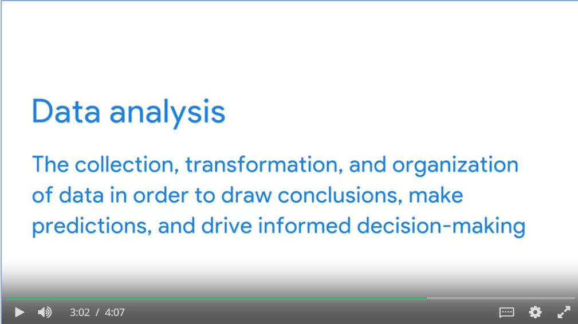

In data analytics, what is the term for elements that interact with one another in order to produce, manage, store, organize, analyze, and share data? (reminder: be sure to scroll down to see all options!)



Data ecosystems



Data compositions



Data maps



Data storage systems

**Correct**

Elements that interact with one another in order to produce, manage, store, organize, analyze, and share data are data ecosystems. These elements include hardware and software tools, as well as the people who use them.

Identify the real-world examples of how a company might make data-driven decisions. Select all that apply.



Choosing e-commerce solutions based on customer shopping preferences

**Correct**

Real-world examples of making data-driven decisions include suggesting new music to a customer, scheduling a certain number of restaurant employees to work, and choosing e-commerce solutions based on established facts. Data-driven decision-making is using facts to guide business strategy.



Making spending decisions based on the gut instinct of the company accountant



Scheduling a certain number of restaurant employees to work based on the average number of lunch-goers per day

**Correct**

Real-world examples of making data-driven decisions include suggesting new music to a customer, scheduling a certain number of restaurant employees to work, and choosing e-commerce solutions based on established facts. Data-driven decision-making is using facts to guide business strategy.



Suggesting new music to a customer based on their listening history

**Correct**

Real-world examples of making data-driven decisions include suggesting new music to a customer, scheduling a certain number of restaurant employees to work, and choosing e-commerce solutions based on established facts. Data-driven decision-making is using facts to guide business strategy.